Ritika Kumari- A20414073

CSP554—Big Data Technologies

Assignment #12

Exercise 1)
Read the article “A Big Data Modeling Methodology for Apache Cassandra” available on the blackboard in the ‘Articles’ section. Provide a ½ page summary including your comments and impressions.
Answer: Apache Cassandra is a leading distributed database of choice when it comes to big data management with zero downtime, linear scalability, and seamless multiple data center deployment. This paper proposes the first query-driven big data modeling methodology for Apache Cassandra, defines important data modeling principles, mapping rules, and mapping patterns to guide logical data modeling, presents visual diagrams for Cassandra logical and physical data models, and demonstrates a data modeling tool that automates the entire data modeling process.
Traditional data modeling methodology, which is used in relational databases, defines well-established steps shaped by decades of database research. A database designer typically follows the database schema design workflow to define a conceptual data model, map it to a relational data model, normalize relations, and apply various optimizations to produce an efficient database schema with tables and indexes. In contrast, known principles used in traditional database design cannot be directly applied to data modeling in Cassandra. Thus, the traditional philosophy of normalization and minimizing data redundancy is rather opposite to data modeling techniques for Cassandra. To summarize, traditional database design is not suitable for developing correct, let alone efficient Cassandra data models.
A database schema in Cassandra is represented by a keyspace that serves as a top-level namespace where all other data objects, such as tables, reside. Within a keyspace, a set of CQL tables is defined to store and query data for a particular application. Paper also explains the table and query models used in Cassandra. Queries over tables are expressed in CQL, which has an SQL-like syntax. Unlike SQL, CQL supports no binary operations, such as joins, and has certain rules for query predicates that ensure efficiency and scalability. The crux of the Cassandra data modeling methodology is logical data modeling. It takes a conceptual data model and maps it to a logical data model based on queries defined in an application workflow. A logical data model corresponds to a Cassandra database schema with table schemas defining columns, primary, partition, and clustering keys. A Cassandra solution architect, a role that encompasses both database design and application design task, starts data modeling by building a conceptual data model and defining an application workflow to capture all application interactions with a database. The application workflow describes access patterns or queries that a data-driven application needs to run against the database.

The following instructions were provided by Prof. Adam McElhinney…
For the remaining exercises you will use an instance of the Cassandra database that you set up in the hadoop sandbox in the Azure cloud. The instructions for installing it and starting the Cassandra shell are as follows:
Open a terminal window and log on to maria_dev. Enable python 2.7:
scl enable python27 bash
export LD_LIBRARY_PATH=/opt/rh/python27/root/usr/lib64/:$LD_LIBRARY_PATH

Verify your Python version is 2.7:
python –version
Install Java version 8 (you might need to supply your root password):
sudo yum install java-1.8.0-openjdk
Check the java version:
java -version
Install wget (you might need to supply your root password):
sudo yum install wget
Download the tarball:
wget http://apache.osuosl.org/cassandra/3.11.3/apache-cassandra-3.11.3-bin.tar.gz

Unpack the tarball:
tar -xvf apache-cassandra-3.11.3-bin.tar.gz
Start Cassandra in the background. This could take 5-10 minutes:
apache-cassandra-3.11.3/bin/Cassandra
Open another terminal window and log on to maria_dev again. Verify Cassandra working:
apache-cassandra-3.11.3/bin/nodetool status
Start the Cassandra shell cqlsh:
apache-cassandra-3.11.3/bin/cqlsh

Note: after you finish this entire assignment you could clean up Cassandra as follows (in the shell):
DROP TABLE emp;
Also drop any other tables you have created.
DROP KEYSPACE dev;
Also drop any other key spaces you have created.

To stop the Cassandra server (in a terminal window):
(Get the pid)
ps ax | grep CassandraDaemon
kill pid

Exercise 2) (2 points)
The following instructions were provided by Prof. Adam McElhinney…
Follow the instructions to create and explore a small Cassandra database…

Create a keyspace:
create keyspace dev with replication = {'class':'SimpleStrategy','replication_factor':1};
Within the dev keyspace, create a table to hold employee data:
use dev;
create table emp (empid int primary key, emp_first varchar, emp_last varchar, emp_dept varchar);
Let's put some data into there:
insert into emp (empid, emp_first, emp_last, emp_dept) values (1,'fred','smith','eng');
Let's modify that data also:
update emp set emp_dept = 'fin' where empid = 1;
Now let's view that data:
SELECT * FROM emp;
As part of the answer to this exercise provide a screen shot of the output of the above select statement.
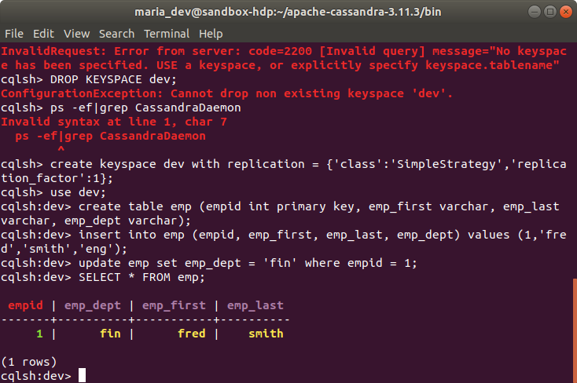

Try a where clause:
select * from emp where empid = 1;
As part of the answer to this exercise provide a screen shot of the output of the above select statement.
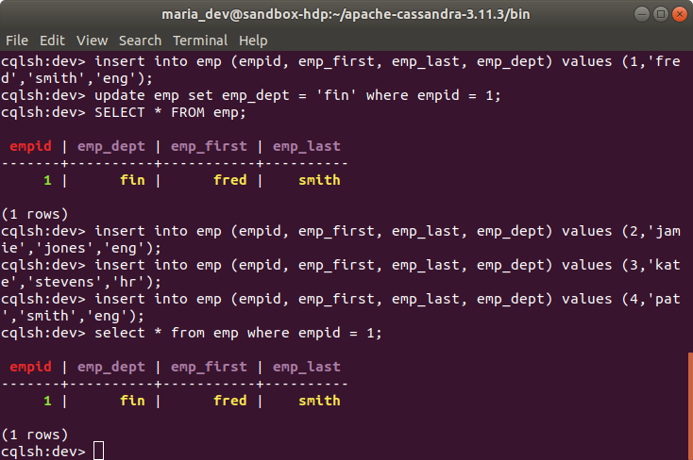

Let's insert some more data:
insert into emp (empid, emp_first, emp_last, emp_dept) values (2,'jamie','jones','eng');
insert into emp (empid, emp_first, emp_last, emp_dept) values (3,'kate','stevens','hr');
insert into emp (empid, emp_first, emp_last, emp_dept) values (4,'pat','smith','eng');
SELECT * FROM emp;
As part of the answer to this exercise provide a screen shot of the output of the above select statement.

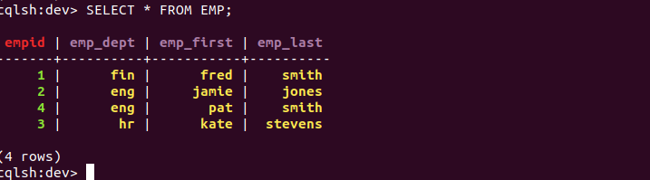
Let's view only the people from engineering:
SELECT * FROM emp WHERE emp_dept = 'eng';
This gives an error because we need a secondary index:
CREATE INDEX emp_dept ON dev.emp(emp_dept);
Now try the query:
SELECT * FROM emp WHERE emp_dept = 'eng';
As part of the answer to this exercise provide a screen shot of the output of the above select statement.
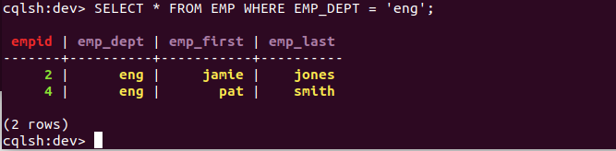

Exercise 3) (3 points)
Now create a file in your working directory called ex3.cql. In this file write the command to create a table named ‘Music’ with the following characteristics:
Attribute Name | Attribute Type | Primary Key / Cluster Key
artistName | text | Primary Key
albumName | text | Cluster Key
numberSold | int | Non Key Column
cost | int | Non Key Column

Execute ex3.cql. Then execute the shell command ‘DESCRIBE TABLE Music’ and include the output as the result of this exercise.
Ex3.cql file script:
create table music (artistName text , albumName text ,numberSold int, cost int, PRIMARY KEY(artistName, albumName));

executed command = SOURCE ‘~/ex3.cql’

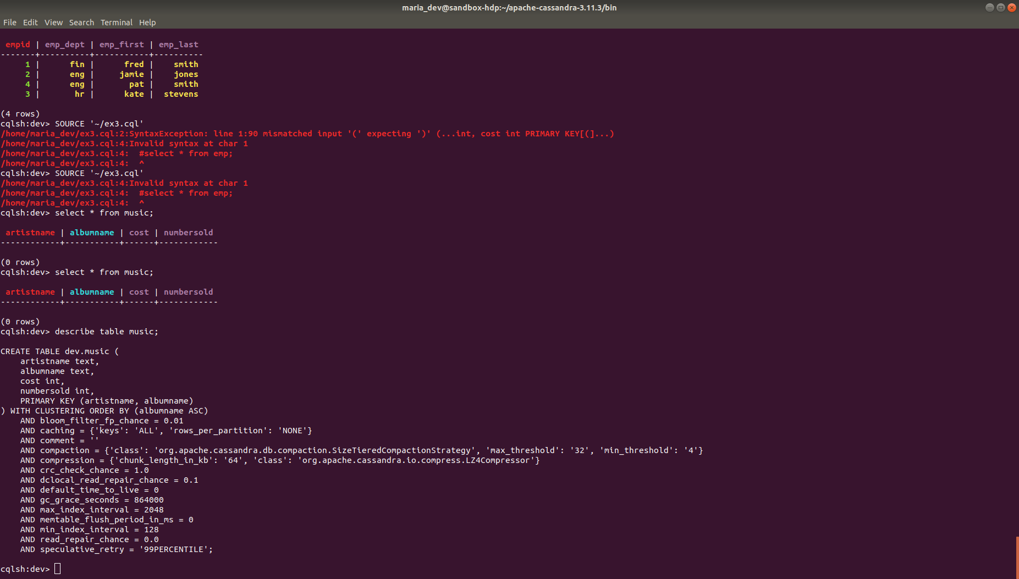

Exercise 4) (3 points)
Now create a file in your working directory called ex4.cql. In this file write the commands to insert the following records into table ‘Music’…
artistName | albumName | numberSold | cost
Mozart | Greatest Hits | 100000 | 10
Taylor Swift | Fearless | 2300000 | 15
Black Sabbath | Paranoid | 534000 | 12
Katy Perry | Prism | 800000 | 16
Katy Perry | Teenage Dream | 750000 | 14

- Execute ex4.cql. Provide the content of this file as the result of this exercise.
- Execute the command ‘SELECT * FROM Music;’ and provide the output of this command as another result of the exercise.

Solution:-

ex4.cql file script:
insert into music(artistName,albumName,numberSold,cost) values('Mozart','Greatest Hits',100000,10);
insert into music (artistName,albumName,numberSold,cost) values('Taylor Swift','Fearless',2300000,15);
insert into music (artistName,albumName,numberSold,cost)values('Black Sabbath','Paranoid',534000,12);
insert into music (artistName,albumName,numberSold,cost)values('Katy Perry','Prism',800000,16);
insert into music (artistName,albumName,numberSold,cost)values('Katy Perry','Teenage Dream',750000,14);

executed script: SOURCE ‘~/ex4.cql’

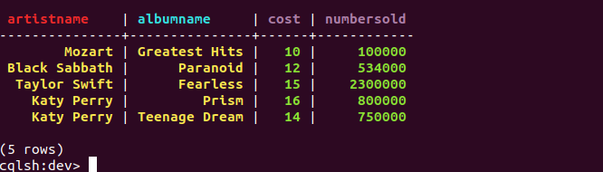

Exercise 5) (3 points)
Now create a file in your working directory called ex5.cql. In this file write the commands to query only Katy Perry songs. Execute ex4.cql. Provide the content of this file and result of executing this file as the result of this exercise.
Ex5.cql file script:
select * from music where artistName = 'Katy Perry';
executed commands: SOURCE ‘~/ex5.cql’
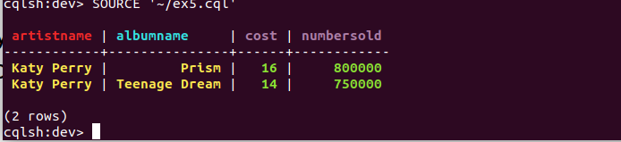
Exercise 6) (3 points)
Now create a file in your working directory called ex6.cql. In this file write the commands to query only albums that have sold 700000 copies or more. Execute ex6.cql. Provide the content of this file and the result of executing this file as the result of this exercise.
Ex6.cql file script:
select * from music where numbersold > 700000 allow filtering;
executed commands: SOURCE ‘~/ex6.cql’

